Team 1 Open Source Air Quality Monitoring

Week 16: April 25th 2022 - May 1st 2022

Sponsor: Dr. [David Burnett](mailto:dburnett@pdx.edu)

Advisor: Dr. John Acken

Team Members: [Adam Dezay](mailto:adezay@pdx.edu), [Manuel Garcia](mailto:manga2@pdx.edu), [Brandon Hippe](mailto:bhippe@pdx.edu), Mercedes Newton

**Team Review:**

* Met with Dr. Burnett to discuss progress as well as giving a demo of the first working prototype of PM and CO2 sensor.
* Discussed switching gears on the Anemometer
* Splitting teams into 2 when we meet for our weekly workshop time
  + Manuel and Brandon will work on code optimization and getting Smartmesh to work
  + Adam and Mercedes will work on PCB design and enclosure
* Moving away from EnergyTrace due to the voltage/current requirements

**Individual Review**

Adam Dezay:

Learning how to design PCB and how to use KiCAD. Updated Wiki. Teaming up with Mercedes to make the enclosure. Writing meeting notes for the week as we make decisions on how we are going into the last stretch of the project.

Manuel Garcia:

Troubleshot briefly Smartmesh with Professor Burnett. Attempted to connect last years capstone project with the host node, however still unable to connect smartmesh node. We are digging into the code for the smartmesh to see what we are missing. Worked on the battery regulating circuit, almost fully complete, however need to find 3.7 to 5v power conversion.

Brandon Hippe:

Started work on power measurements, using Joulescope instead of EnergyTrace due to 5V requirement and current specs. Wrote a python program to calculate measurement periods based on power consumption. Fixed CO2 sensor not sleeping

Mercedes Newton:

PM2.5 sensor updates - Worked on debugging some of the pm2.5 sensor code. Started the process of designing our PCB and physical CAD model. Making key decisions that will affect where things go and mount and should start serious drafting in the coming weeks.

**Gantt Chart and Timeline Updates:**

Below is both the timeline of the projected project progress for spring term. Figure 1 represents the gantt chart for the term with expected completion dates beginning March 25th. All specific dates for the upcoming term are specified in the table below.

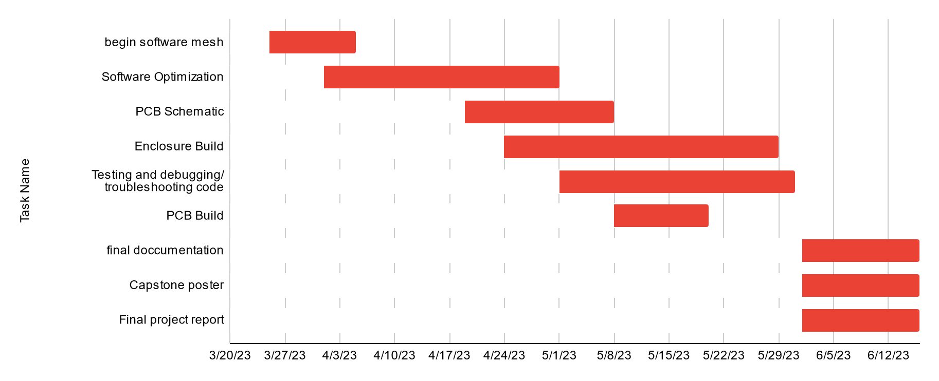

Figure One: Gantt chart for spring term (first task starts 3/25/2013)

| Task Name | Start date | End date |
| --- | --- | --- |
| Begin software mesh | 3/25/2023 | 4/5/2023 |
| Software Optimization | 4/1/2023 | 5/1/2023 |
| PCB Schematic | 4/19/2023 | 5/8/2023 |
| Enclosure Build | 4/24/2023 | 5/29/2023 |
| Testing and debugging/ troubleshooting code | 5/1/2023 | 5/31/2023 |
| PCB Build | 5/8/2023 | 5/20/2023 |
| final documentation | 6/1/2023 | 6/16/2023 |
| Capstone poster | 6/1/2023 | 6/16/2023 |
| Final project report | 6/1/2023 | 6/16/2023 |

Table One: Tasks for spring term with expected completion dates *completion dates subject to change*

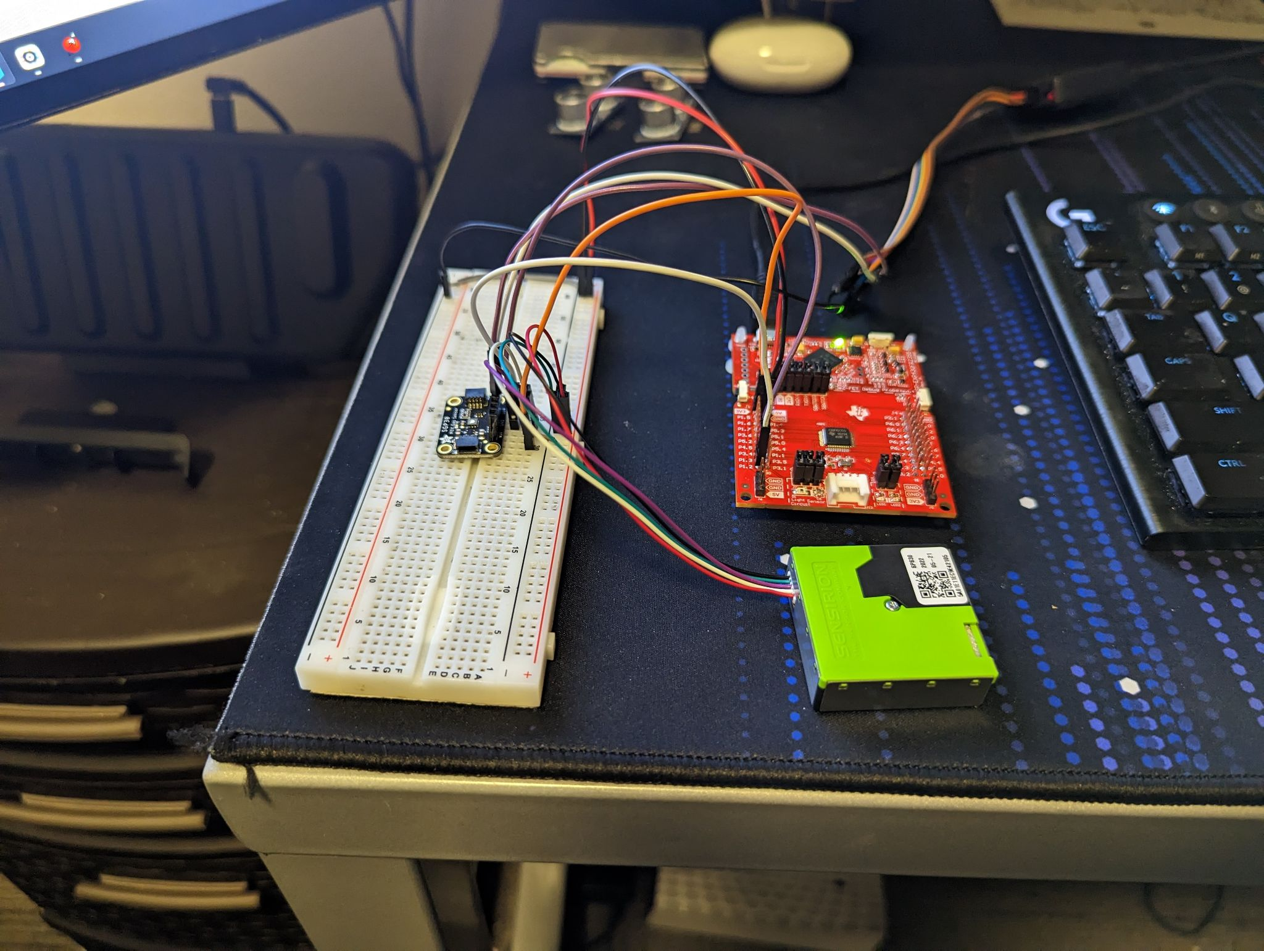

Figure Two: Image of Breadboard prototype

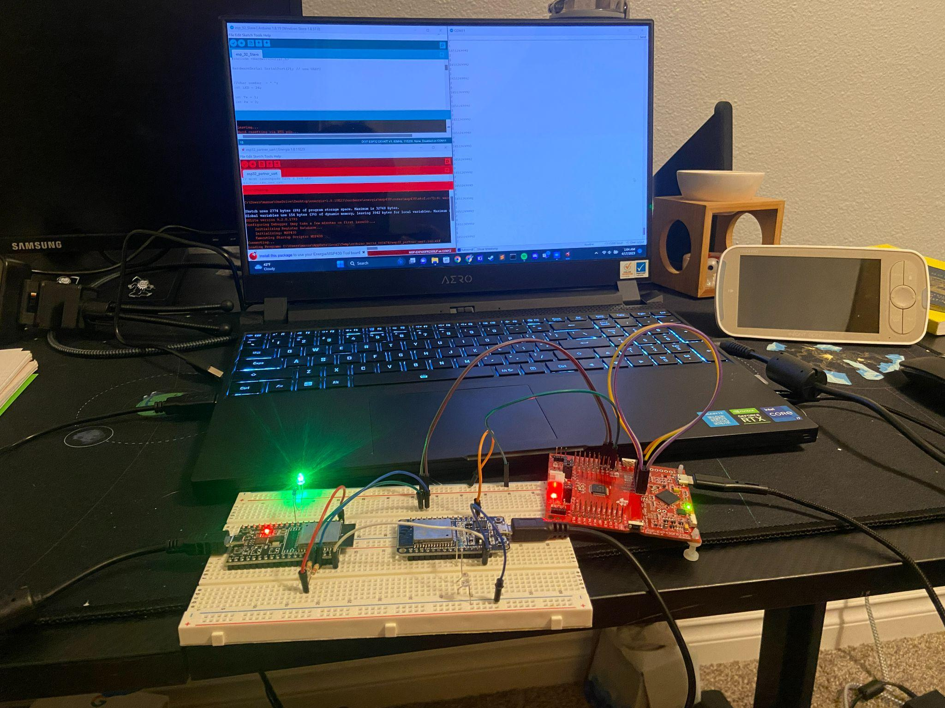

Figure Three: MSP430 transmitting to esp32 webserver

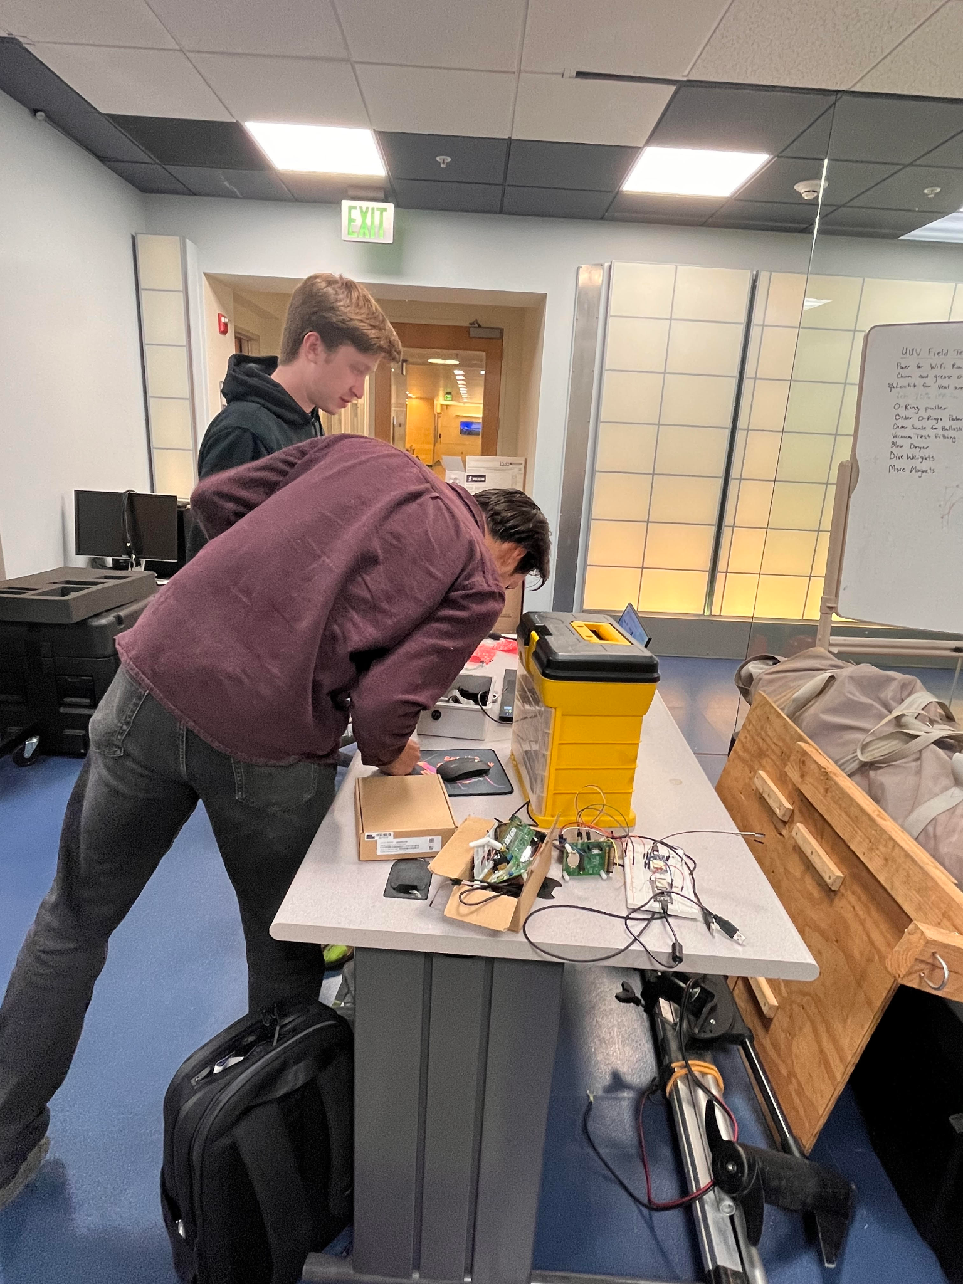

Figure Four: Team working during one of our three weekly meetings